PRODUCT DEFINITION REPORT
TEAM 2
Ekim Kurtulmaz
Kaan Denizer
Serkan Atrek
Gökhan Toker
Mehmet İveynat

Date: 26.10.10

Table Of Contents
Definition of the Product........................................................................................................3
Physical Characteristics..........................................................................................................5
Interface Software...................................................................................................................7
The Standarts of Product........................................................................................................9
References...............................................................................................................................10

1. Definition of the Product
Our product is basicly a smart board system that is designed to be used in lectures and conferencess. Main idea of our system is to capture the movement of the colored board marker on a regular board and save these movements as images in a computer. According to our design, two wide-angle cameras (one camera for each axis) that are placed up and right edges of a board will catch the motion of the certain axis movements of a colored board marker and send images simultaneously to the computer. Afterwards both images will be cropped to adjust the range we want to process. Then the images will be digitally processed by the algorithm that we create so we can find the location of the colored board marker by using a software program. To do these image processing operations, we are considering c++ and opencv. The algorithm will detect the color of the pencil. By using these, we will determine x and y axis of the board marker according to a virtual origin on the board. This data will be used to draw what is on the board pixel by pixel. To manage the drawing action on computer, we plan to create our own drawing program with java or c++ since communication with “Paint” may cause some problems. In addition, if we want to track our colored board marker, we have to pick a color that can always be distinguished from other colors in any time of the day. We have to avoid light reflections and shadow effects to get the perfect result. We also need to be careful about the calibration of the cameras. After successfully building the basic design, there are some applications that we would like to add to improve our product. Different writing color and eraser applications are some of them.

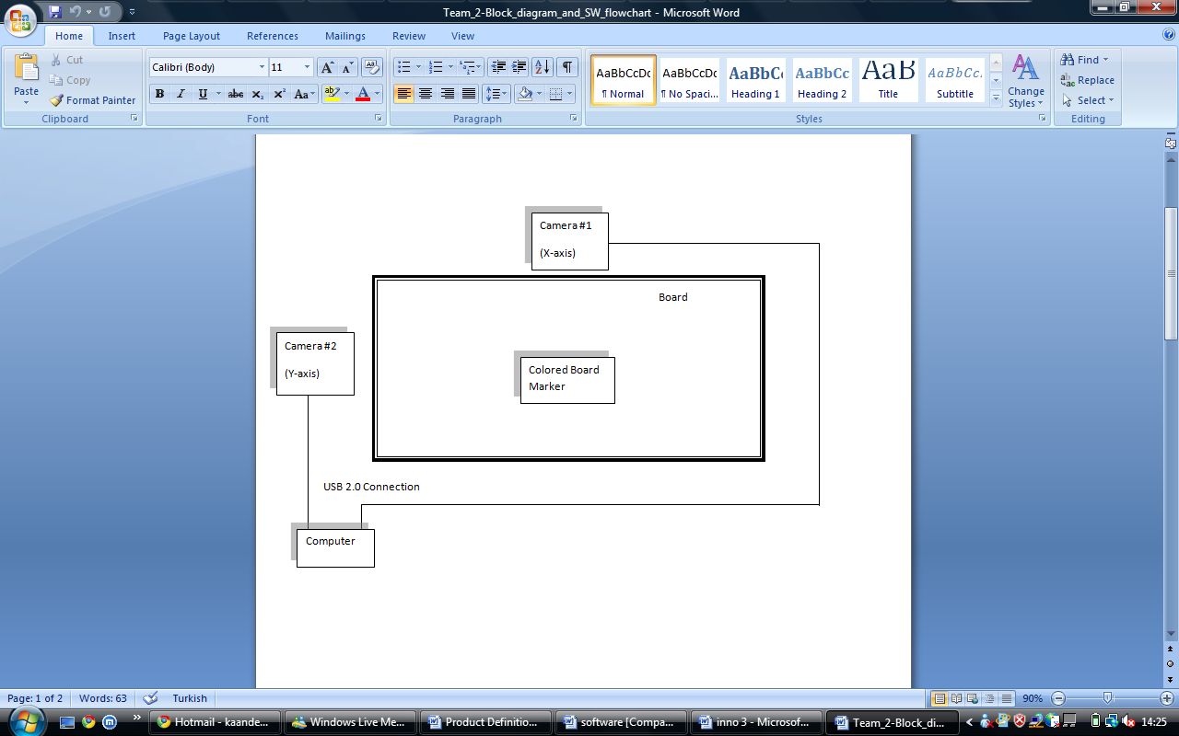

Figure 1: Flow chart diagram

2. Physical Characteristics
Camera
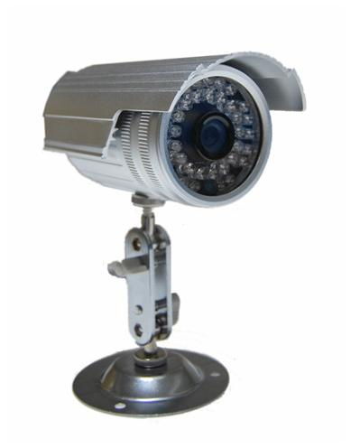Figure 2: Camera
- The supporter part of the camera is consisting of a plate (Radius = 2.5cm) that will be placed at the wall and a metal bar (Length = 6cm)that holds the camera.
- The camera’s outside shell is a cylinder which has a height of 15 cm and radius of 2.5cm.
- The total camera system weights approximately 3 – 5 kg
DVR Card
. 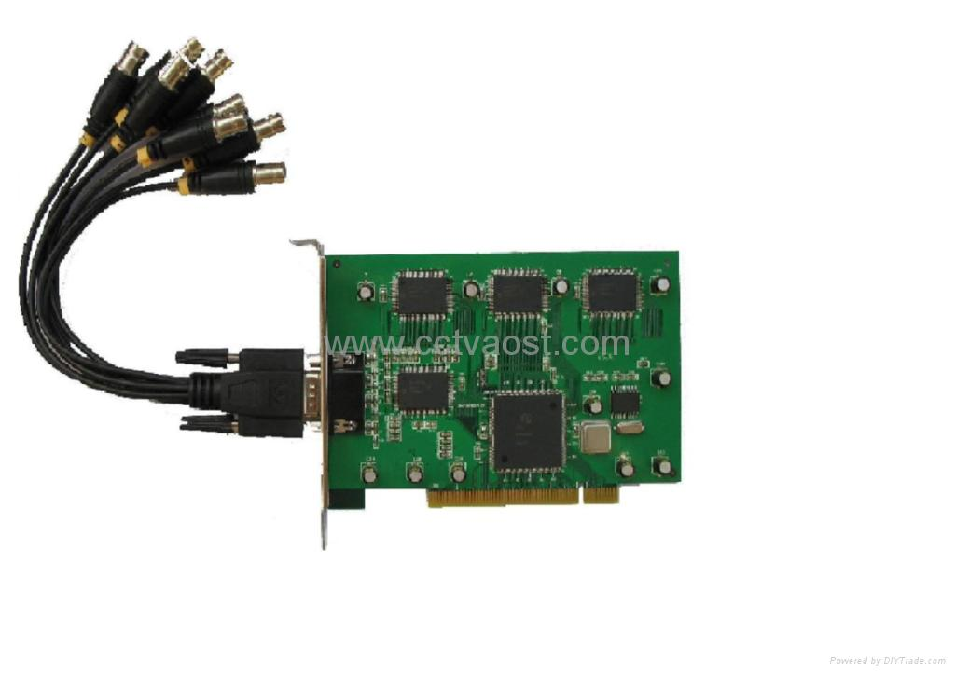
Figure 3: DVR Card
Dvr Card is rectangular shaped compenent.(7cmx15cm). It weights approximately 1 kg .

Board Marker
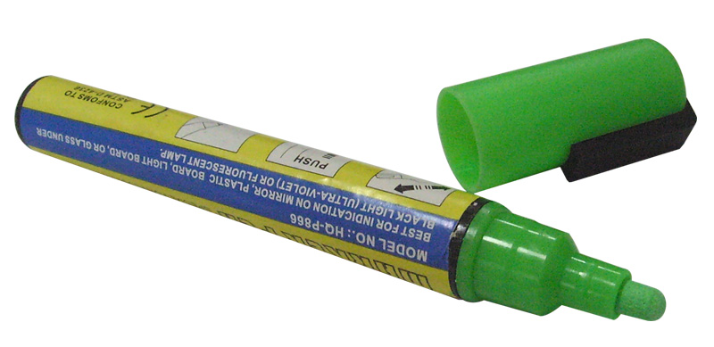
Figure 4: Board Marker
A board marker which has been paint with distinct color will be used. It will have the dimensions of a regular board marker. A cylinder with height of 7 cm and radius of 1cm.

3. Interface and Software:

We will use a software program to analyze the image continuously and find the coordinates of the pen. After obtaining the location of pen on the board, we need another program to draw the pixels that pen locates.
We will use Open Computer Vision Library(OpenCv) to process the data that is transmitted by DVR card[1]. OpenCv would take the data from the cameras and by using image processing techniques and transforms, it would obtain the location of the pen on the board.
OpenCv is a digital image processing tool that provides many features like object identification, motion understanding and tracking. With using object identification and motion tracking, it can detect the pen and track its motion during the video. Furthermore it allows user to use Fast Fourier Transform (FFT) and Image Transform. The program can work in both 2D and 3D images.
In order to draw the images we will use drawing tools of C++. The program would take the data of the location from image processing program and draw the pixels according to them simultaneously.
Camera Properties(095441):
- Image Sensor: ¼ inch SONY Super Had CCD scan area height = 5.2 mm, width = 4.8 mm
- Horizontal Resolution: 420 Television Lines(TVL)
- Automatic Iris Control:
The lens of the camera automatically adjusts the level of light just like human eye.
- Gamma value(encoding gamma) : 0,45
Gamma correction describes a nonlinear process that blackens or enligthens the video or image. For gamma = 1, there is no coding or encoding, so the image would remain same. For gamma = 0,45 the image would be lighter than its normal.
- Auto Gain Control
A feedback system that amplifies the input if it is strong or deamplifies it if it is weak. Without automatic gain control system, the output may vary in huge range and system would be inefficient.[2]
- Back Light Control
Back Light Control operates if there is light coming beh’nd the camera. Avoids the defects when there is a light behind the camera. Provides the camera good quality of images
- 4 mm. Lens
- Operating Voltage:12 V DC
- Power consumption: 1A (max 1.5 A)[3]
Digital Video Recorder(DVR) Card Properties:
- Scanning speed: 100 Fps
- Multiple display: 1/4/9/16 channel display
DVR can outputs more than one screen at the same time.
- Definition: 320x240,352x288, 640x480
- Video Format: PAL/NTSC
NTSC format uses phase correlation. There may have some errors about color encoding due when phase of the video signal is oscillating. PAL format uses a delay to get rid of errors.
- Network Transfer
- Operating System: Windows XP

4. The standards of Product
There is a small amount of radiation that every people exposed during daily life which is called background radiation or natural radiation. Our Smart Board system produces less than 1m-rem(rontgen equivalent man) which is around natural radiation.

5. References:
- sourceforge.net/projects/opencvlibrary/
- http://www.nap.edu/openbook.php?record_id=10094&page=281
- http://www.kaanguvenlik.com/online/Scripts/prodView.asp?idproduct=565

